Gantt Chart

This is the Gantt Chart shows our original planned working schedule. This Gantt Chart was not changed frequently because we always tried our best to follow the original plan and avoid making changes.

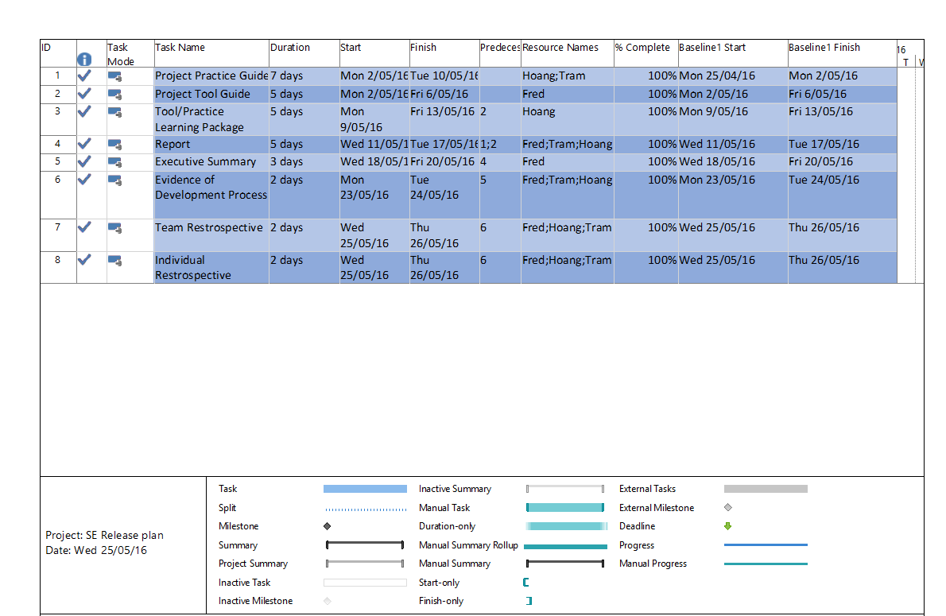

Network Diagram

This two network diagram that shows our activity sequencing. It clearly shows the relationship, dependencies between project tasks. Most of our tasks are dependent on one another and they needed to be completed in a rigorous order of: Project Practice Guide – Project Tool Guide – Project Tool Learning Package – Report – Executive Summary – Team retrospective/Individual retrospective. This order is specified based on the team decision which we believe that it is the most reasonable and fastest way to complete this project.

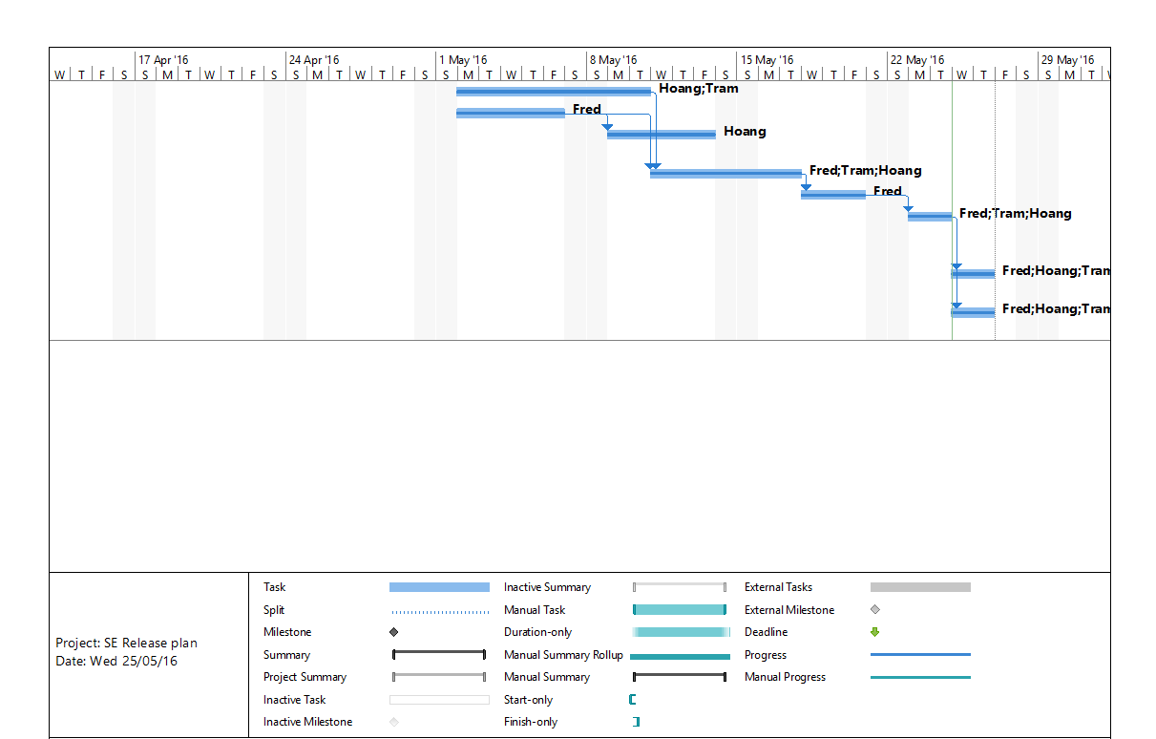

Crossed out activities are finished. All of them are finished by the due date of the project.

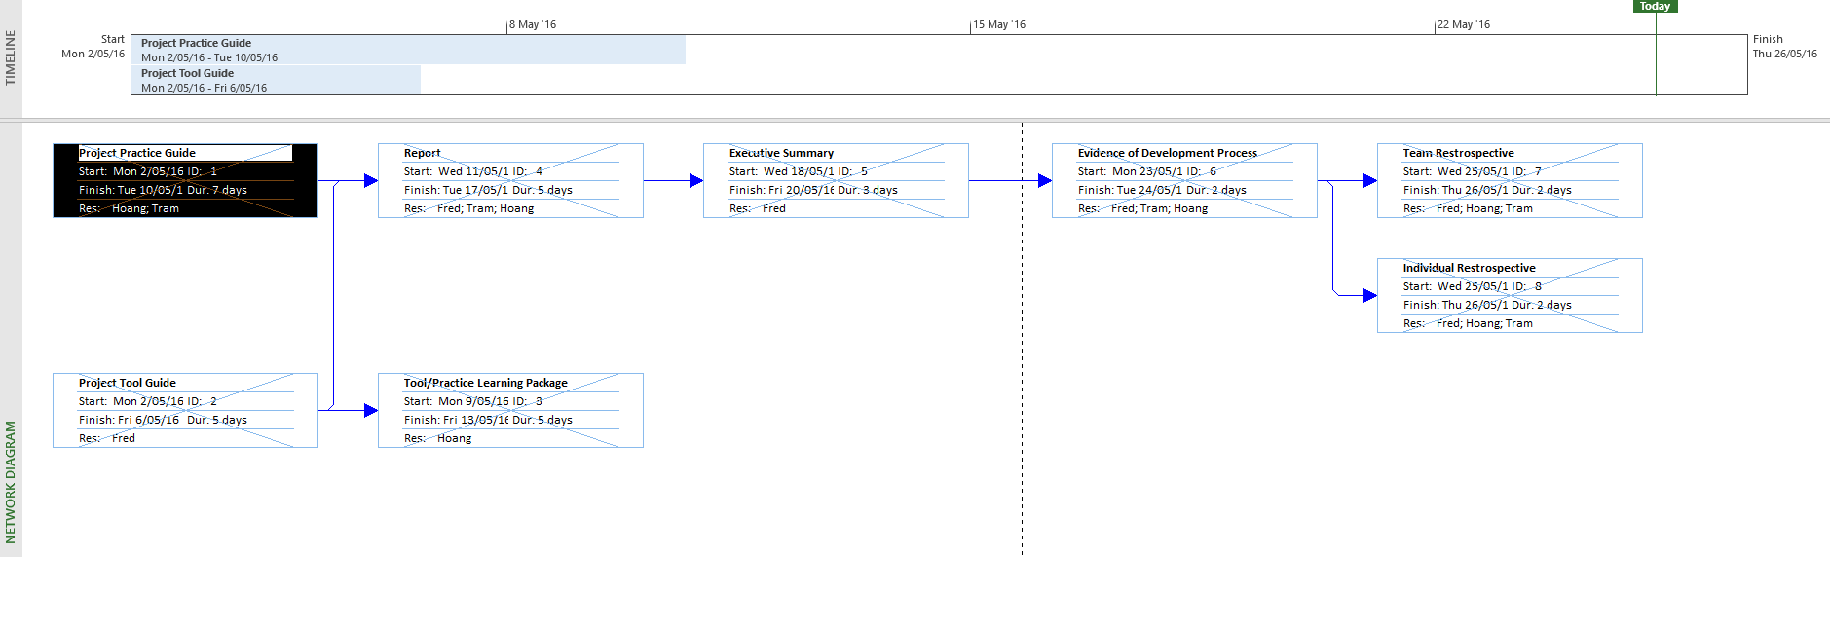

Tracking Gantt Chart

The Tracking Gantt Chart is updated frequently based on the work progress. A task is considered to be completed when it % complete hits 100.

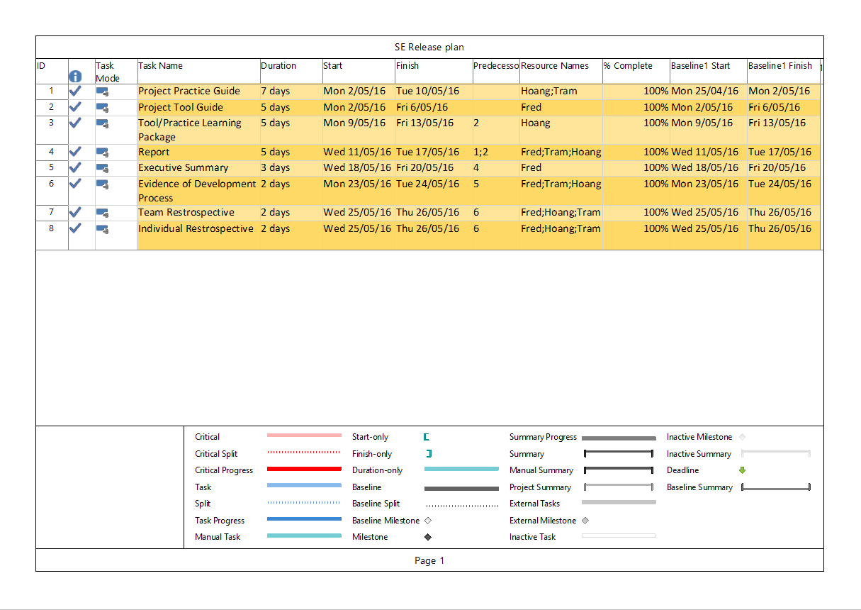

This network diagram shows our planned schedule (the blue bar) and compares it with the actual start date and finish date (the grey bar) which is indicated as Baseline1 start and Baseline1 finish respectively in the Tracking Gantt Chart. We started the work 1 week earlier than the original plan (during mid-semester break) because we think there will be a lot of other assignments to work on after the break. The sooner the team start, the more secure that the project will be completed on time.

